Github代码：

https://github.com/aosp-mirror/platform_frameworks_base

Android API Levels: https://apilevels.com/

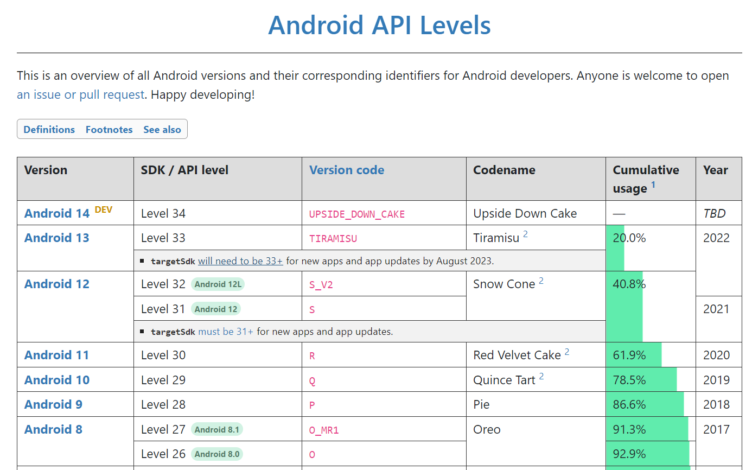

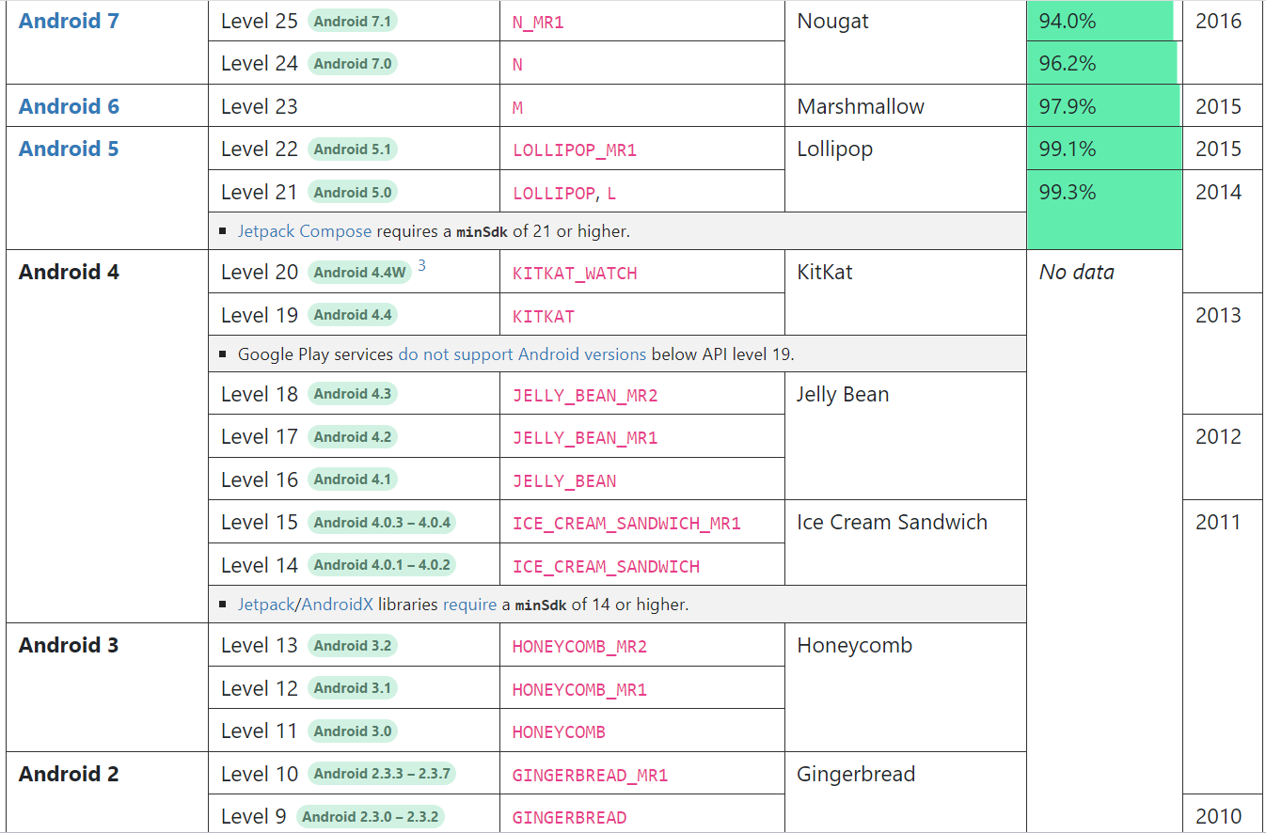

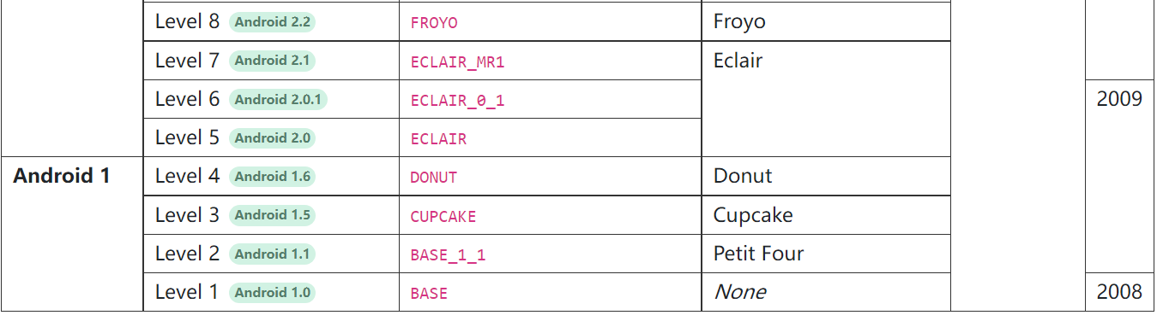

Android git: https://android.googlesource.com/platform/frameworks/base.git/+refs

Psd: level 1 – 10, 21 - 25

Gtc: level 11 – 20, 26 – 34

找到对应版本 -> core(点进去第五个) -> java -> android, com, org

**Shidong Pan:**

|  |  |  |  |  |
| --- | --- | --- | --- | --- |
| API Level Information | Android Version | Availability | Path | Comment |
| Level 1 | Android 1.0 | N |  |  |
| Level 2 | Android 1.1 | N |  |  |
| Level 3 | Android 1.5 | N |  |  |
| Level 4 | Android 1.6 | Y | API/android-1.6_r2 |  |
| Level 5 | Android 2.0 | Y | API/android-2.0_r1 |  |
| Level 6 | Android 2.0.1 | Y | API/android-2.0.1_r1 |  |
| Level 7 | Android 2.1 | Y | API/android-2.1_r2 |  |
| Level 8 | Android 2.2 | Y | API/android-2.2_r1 |  |
| Level 9 | Android 2.3.0-2.3.2 | Y | API/android-2.3.1_r1 |  |
| Level 10 | Android 2.3.3-2.3.7 | Y | API/android-2.3.3_r1 |  |
| Level 21 | Android 5.0 | Y | API/android-5.0.0_r1 |  |
| Level 22 | Android 5.1 | Y | API/android-5.1.0_r1 |  |
| Level 23 | None |  |  | ? |
| Level 24 | Android 7.0 | Y | API/android-7.0.0_r1 |  |
| Level 25 | Android 7.1 | Y | API/android-7.1.0_r1 |  |